***Eugene Figure Skating Club   
presents***

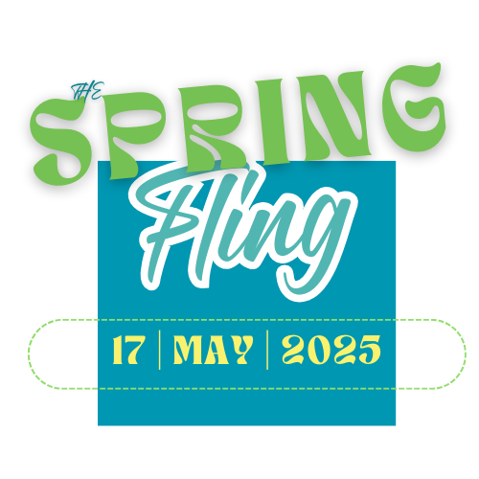

**You are invited to participate in the Eugene Figure Skating Club’s annual spring production!**

This is a wonderful opportunity for our skaters to perform in front of an audience and show what you have learned!

**Sign-up by May 2nd .** Return the attached form to register. There is a **$50** participation fee to help cover expenses, such as ice rental fees, costuming and coach expenses.

Rehearsal Schedule:

**Tuesdays, May 6th and May 13th**

*Advanced levels 5:30 – 6:15 pm; Beginner levels 6:10 – 6:45 pm, unless otherwise noted.*

**Saturday, May 10th**

*Advanced levels 11:15 am – 12:00 pm; Beginner levels 11:55 – 12:30 pm, unless otherwise noted.*

**Saturday, May 17th – 11:15am to 12:30 pm (Dress Rehearsal)**

~ Please return this portion with your payment ~

***The Spring Fling***

2025 **Group Participant** Sign-up

**Please print legibly**  
Skater Name___________________________________________ $50 Paid? ______________

Skater’s Class Level____________________________________________

Parent Signature________________________________________ Date__________

Contact Email________________________________________________________

**Parent involvement is critical to the success of our show! Please indicate how you can help on the form below (check all that apply!)**

Parent Name _________________________________________

_____ Back stage duties before & during show

_____ Sell tickets for prize drawings at   
 performance

_____ Lobby greeter

_____ Costumes or set creation in the weeks   
 before the show

Tell parents to print legibly as this is used to put names in program

Announce – don’t let ability to pay fee upfront or come to all rehearsals impede participation – talk to us

Need parent volunteers -